Shari/Display via HDMI - INFO (Rasbi 3+)

Auspacken und mit Win32DiskImager auf eine 16 GB SanDisk SD Karte schreiben.
Mit PuTTY SSH Client user pi PW dg5nek einlogen.

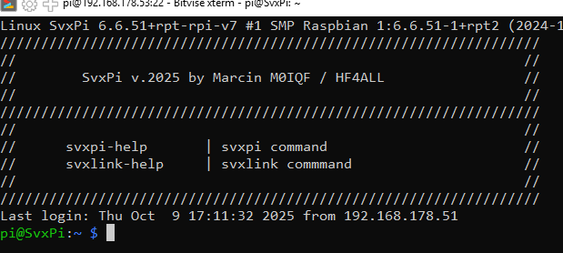
Mit sudo raspi-config

1 System Option dann S1 Wireles LAN einstellen.
SSID Super**** Schlüssel 90***************212
6 dann A1 SD Karte Speicher frei machen -> Reboot

update und upgrade Rasbi
sudo apt-get update
sudo apt-get upgrade

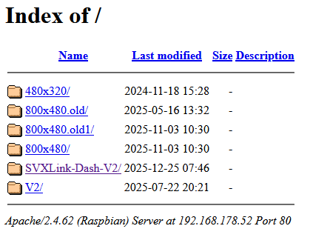
V2 Normal…
svxpi-ref1 z.B. bis svxpi-ref5
DG6IQ-HS (HS2,L usw.) 430.1000MHz

#!/bin/bash
###############################################################
config_file="/etc/svxlink/svxlink.conf"

# Neue Werte
new_callsign="DG6IQ-HS"
new_auth_key="******************"
new_default_tg="90574"
new_monitor_tgs="26284,97265,90574++"
new_fmnet="DG6IQ-HS 430.100MHz 1"
new_api=""
#new_dns_domain="fm-funknetz.de"
new_DNS_DOMAIN=reflector-network.eu
###################################################################

# HOSTS und DNS_DOMAIN gleichzeitig setzen
sed -i "s/^HOSTS=.*/HOSTS=$new_host/" "$config_file"
sed -i "s/^DNS_DOMAIN=.*/DNS_DOMAIN=$new_dns_domain/" "$config_file"

# Weitere Einstellungen
sed -i "s/^HOST_PORT=.*/HOST_PORT=$new_port/" "$config_file"
sed -i "s/^CALLSIGN=.*/CALLSIGN=$new_callsign/" "$config_file"
sed -i "s/^AUTH_KEY=.*/AUTH_KEY=$new_auth_key/" "$config_file"
sed -i "s/^DEFAULT_TG=.*/DEFAULT_TG=$new_default_tg/" "$config_file"
sed -i "s/^MONITOR_TGS=.*/MONITOR_TGS=$new_monitor_tgs/" "$config_file"
sed -i "s/^FMNET=.*/FMNET=$new_fmnet/" "$config_file"
sed -i "s|^API=.*|API=${new_api//\//\\/}|" "$config_file"

sudo systemctl restart svxlink
_ Strg+o (speichern) Strg+x -> (Eingabeaufforderung)_______________________________________

INFO Datei -> mit SSH Client ändern Strg+o (speichern) Strg+x -> (Eingabeaufforderung)

z.B.

svxlink-info

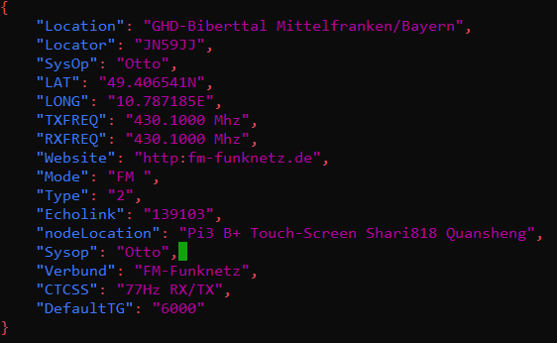

Mit SSH (putty) ändern und speichern Strg+o (speichern) Strg+x -> (Eingabeaufforderung)

{
"Location": "GHD-Biberttal Mittelfranken/Bayern",
"Locator": "JN59JJ",
"SysOp": "Otto",
"LAT": "49.406559",
"LONG": "10.787257",
"TXFREQ": "Network",
"RXFREQ": "Network",
"Website": " www.qrz.com/db/DG6IQ",
"Mode": "FM ",
"Type": "3",
"Echolink": "139103",
"nodeLocation": "Pi3 B+, Touch-Screen, GHD-Biberttal Mfr./By",
"Sysop": "Otto",
"Verbund": "FM-Funknetz",
"CTCSS": "None",
"DefaultTG": "4711"
}

Buttons (Key) ändern

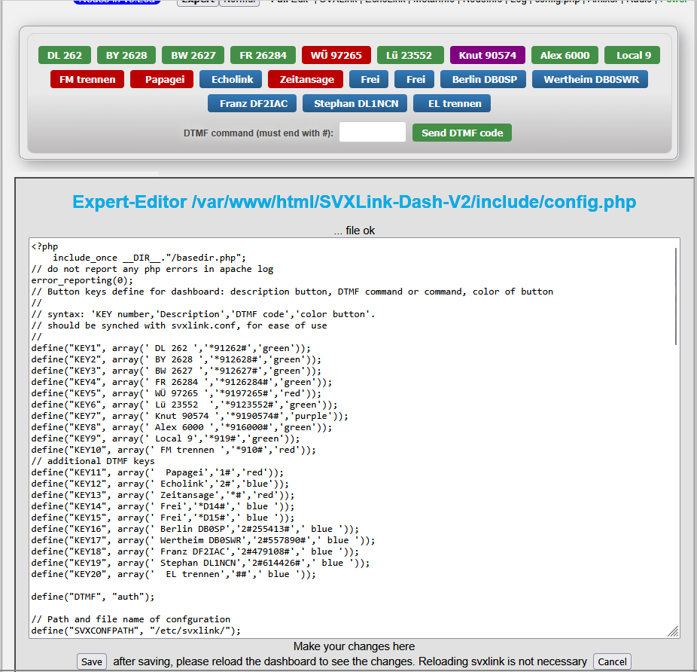

Save nicht vergessen…

EchoLink
sudo nano /etc/svxlink/svxlink.d/ModuleEchoLink.conf

[ModuleEchoLink]
NAME = EchoLink
ID = 2
TIMEOUT = 900
MUTE_LOGIC_LINKING = 1
#ALLOW_IP = 192.168.1.0/24
#DROP_ALL_INCOMING = 0
#DROP_INCOMING = ^()$
#REJECT_INCOMING = ^()$
#ACCEPT_INCOMING = ^(.*)$
#REJECT_OUTGOING = ^()$
#ACCEPT_OUTGOING = ^(.*)$
#REJECT_CONF = 0
#CHECK_NR_CONNECTS = 2,300,120
SERVERS = servers.echolink.org
CALLSIGN = DG6IQ-L
PASSWORD = ********
SYSOPNAME = Otto
LOCATION = [Svx] Grosshabersdf./Mfr.By.
#PROXY_SERVER = elp083.pi9noz.hamnet.nl
#PROXY_SERVER = 137.226.114.85
#PROXY_SERVER = 44.137.75.176
#PROXY_SERVER = PUBLIC
#PROXY_PORT = 8100
#PROXY_PASSWORD = PUBLIC
#BIND_ADDR = 10.20.30.40
MAX_QSOS = 10
MAX_CONNECTIONS = 11
LINK_IDLE_TIMEOUT = 300
#AUTOCON_ECHOLINK_ID = 9999
#AUTOCON_TIME = 1200
#USE_GSM_ONLY = 1
#DEFAULT_LANG = de_DE
#COMMAND_PTY = /dev/shm/echolink_ctrl
#LOCAL_RGR_SOUND = 1
#REMOTE_RGR_SOUND = 0
DESCRIPTION = "You have connected to a SvxLink node,\n"

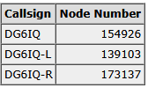

Expert-Editor /etc/svxlink/svxlink.conf

sudo nano /etc/svxlink/svxlink.conf (Mit SSH putty ändern…)
[SimplexLogic]
TYPE=Simplex
RX=Rx1
TX=Tx1
MODULES=ModuleHelp,ModuleParrot,ModuleEchoLink

CALLSIGN=DG6IQ
SHORT_IDENT_INTERVAL=0
LONG_IDENT_INTERVAL=0
EVENT_HANDLER=/usr/share/svxlink/events.tcl
DEFAULT_LANG=de_DE
RGR_SOUND_DELAY=10
RGR_SOUND_ALWAYS=1
FX_GAIN_NORMAL=-5
FX_GAIN_LOW=-12
QSO_RECORDER=8:QsoRecorder
DTMF_CTRL_PTY=/tmp/dtmf_svx
MUTE_RX_ON_TX=1
MUTE_TX_ON_RX=1

[ReflectorLogic]
TYPE=ReflectorV2
DNS_DOMAIN=reflector-network.de
#HOSTS=fm-funknetz.de
#HOST_PORT=5308
CALLSIGN=DG6IQ-HS
AUTH_KEY=***************
DEFAULT_TG=90574
MONITOR_TGS=9+,262,2628,26284,26390,26391,6000,97265,90574++
FMNET=DG6IQ-HS 434.975Mhz
API=
#JITTER_BUFFER_DELAY=0
TG_SELECT_TIMEOUT=180

_ Strg+o (speichern) Strg+x -> (Eingabeaufforderung)_______________________________________

USER Daten: (ändert nur für das Display…) ssh PuTTY usw.
sudo nano /var/www/html/800x480/include/userdb.dat

'DG5NEK-BS' => 'JN59CX, Heribert, Heidenfeld',
'DG5NEK' => 'JN59CX, Heribert, Heidenfeld',
'DG5NEK-L' => 'JN59CX, Heribert, Heidenfeld',
'DG5NEK-L2' => 'JN59CX, Heribert, Heidenfeld',
'DG5NEK-HS' => 'JN59CX, Heribert, Heidenfeld',
'DL3MX-L' => 'JN58QC, Alfred, BY Germering nr Munich',
'DL3MX-HS' => 'JN58QC, Alfred, BY Germering nr Munich',
'DL3MX-N1' => 'JN58QC, Alfred, BY Germering nr Munich',
'DL3MX-N2' => 'JN58QC, Alfred, BY Germering nr Munich',
'DG3NCZ-BS' => 'JO50A, Herman, Zeil am Main',
'DD9MI-HS' => ', Friedhelm, Zeil am Main',
'DL4EM-HS' => 'JN, Frank, Frankfurt',
'DG6IQ-HS' => 'JN59JJ, Otto, Großhabersdorf Mfr./BY.',
'DG6IQ-HS2' => 'JN59JJ, Otto, Großhabersdorf Mfr./BY.',
'DG6IQ-APP' => ' Galaxy S25 Ultra, Otto, Großhabersdorf Mfr./BY.',
'DG6IQ-L' => 'JN59JJ, Otto, Großhabersdorf Mfr./BY.',
'DG6IQ' => 'JN59JJ, Otto, Großhabersdorf Mfr./BY.',
'DL9NAZ-HS' => '***, Knut, Roßtal Mfr./BY.',
'DL9NAZ-iOS' => 'iPhone, Knut, Roßtal Mfr./BY.',
'DG6IT-HS' => 'JN49SR, Volkmar, Urpha/Wertheim BW',
'DF2IAC-HS' => 'JN49VQ, Franz, Gerchsheim BW',
'DF2IAC-APP' => '***, Galaxy S22, Franz, Gerchsheim BW',
'DL8NDS-APP' => '***, Dieter, Würzburg',
'DH1NGL-HS' => 'JO50TE, Georg, Marktleugast',
'DH1NGL-HS2' => 'JO50TE, Georg, Marktleugast ',
'DK3AT-WEB' => 'JO50DX, Tino, Erbstromtal TH',
'DK5AC-HS' => 'JN50UH, Albert, Naila',

DG s Daten: (ändert nur für das Display…) ssh PuTTY usw.
sudo nano /var/www/html/800x480/include/tgdb.dat

'90574' => 'Rangau Roßtal',
'97265' => 'Hettstadt Würzburg'
'6000' => 'Trautmannshofen',

_ Strg+o (speichern) Strg+x -> (Eingabeaufforderung)_______________________________________

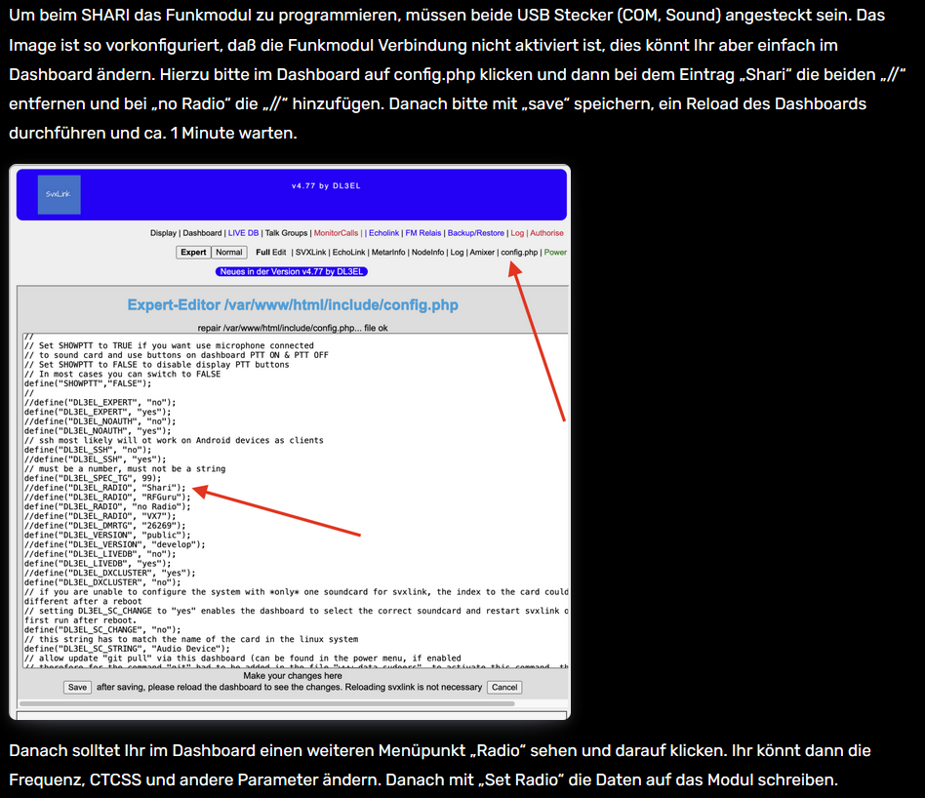
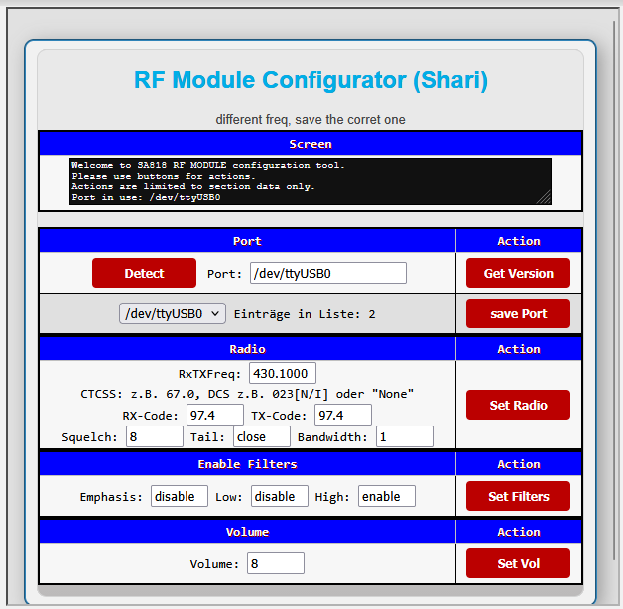

Call und Zeitansage Shari

Expert-Editor /etc/svxlink/svxlink.conf

Short alle 30 min Call / Long alle 60 mim Zeit Direkt -> *#

Mehrere Netzwerke konfigurieren mit sudo nmtui

Wichtig -> Strg+o (speichern) Strg+x -> (Eingabeaufforderung) [(pi@SvxPi:~ $]

DG6IQ Otto edit 31Dez2025

